Written by Thomas Graham, with contributions from Matthew Singh, Carson Ward et al.

tdrgraham@gmail.com

Student Handout

This document is intended as a complementary product in order to supplement the in-person learning of content due to the fast-paced nature of this lecture series. However, the document has been designed to act as an independent learning tool and is therefore useful for comprehensive reference after a lecture, or for self-teaching. Any questions or feedback should be directed towards the author.

Lesson 1: Basics of show control - lighting

West Island College Department of Drama - 2021

INTRO

Thanks for joining us on your journey to becoming officially qualified technicians within the WIC department of drama. We’d like to emphasize the use of *journey* as that’s exactly what this learning process is. There will not be a point at which you can declare you know everything there is to know, and we’d encourage you to remember that as you become more skilled in working in your department.

For this first lesson, we’re going to take a brief look at the very basics of lighting theory and programming with ETC Eos software. This guide and accompanying presentation are not designed to teach you design theory, solely technique for programming and acting as a technician. Furthermore, this lesson does not include everything you need to begin and follow up training is required to continue programming with us.

So, where do we get started?

LIGHTING – WHAT IS IT?

No matter your background, you probably have some preconceived notions about the purpose behind theatrical lighting. For some, lighting is a utilitarian tool, one that is used to meet an objective (allowing people to see) and nothing else. However, the more commonly accepted view of stage lighting is one that refers to light as an artistic medium. By seeing lighting as something we can use to channel an artistic vision and communicate thought/emotion/situation, our ability to enhance a particular production is enhanced greatly. While these thoughts might be better off in a guide to design theory, we felt them to be worth mentioning.

So, how do we light things? At the very core of it, there are three entities in the lighting workflow. There’s a fixture (the fancy name for lightbulb), which provides the physical light. There’s a human, who decides what the fixture does and when. Finally, there’s an interface between the two. This interface is just as necessary as the two other parts and is the core of what we’re talking about in this lesson.

In your own house, this “interface” is often a simple switch. Flip it on, and a circuit is closed, allowing electricity to flow to a bulb. Hence, the light turns on. This is as simple as it gets. Now, this would be perfectly adequate in stage lighting if you (the designer/programmer) were content with just switching things on and off throughout the show. However, as artists we tend to be a bit pickier, and so we rely on the concept of the dimmer. By relying on something that is *variable* (sliding scale) as opposed to *binary* (on/off), we open up a whole new realm of possibilities. As we move further along the technological timeline, we learn that this variable technology need not only apply to the brightness (or intensity) of a light, but its color, among other things.

However, controlling fixtures with dimming technology is a lot more complex than using a simple switch, particularly if you have more than one fixture (think 10, 20, 50, 100s). This is why we have the interface. In the old days, this was a physical device, which used hardware to control fixtures. Nowadays, we use software. That’s what this lesson is all about.

Here at WIC, we use a software called “Eos” from Electronic Theatre Controls (ETC) and run this software on a physical board called “Element.” The first two of these are key.

Here at WIC, we use two core types of fixture: the incandescent and the LED. The incandescent is the one we’re all used to in our homes (traditionally). For our purposes, the important restriction of incandescent light is that it is dimmable in intensity only. In other words, the color cannot change. Varying amounts of electricity are sent to the bulb, which in turn affects its brightness. The LED makes up the bulk of our inventory and is unique in a number of ways. In contrast to the incandescent bulb, the LED can change color and intensity (electronically controlled, rather than simple variance in electricity). It’s seriously awesome, but we’ll touch on that in a later lesson.

Using our interface, we assign fixtures a unique ID within our show file. This is called the “channel.” The channel is the basis for much of what you’ll do with the software and is a very common term. Think, “1 channel = 1 fixture = 1 lightbulb.”

Because all of this is controlled electronically, it is now possible to run interface software (more commonly called “show control”) off any computer. While being on a physical board helps (due to its keyboard layout and connection to lights), practicing the software offline can be of great benefit when you don’t have easy access to a board. The learning here can be applied to either one, with a different keyboard being the only learning curve.

GETTING SET UP

Now, in order to run lighting software on your computer, you obviously need to download the software first. To download ETC software on your personal machine, the following steps should be taken:

For those of you who are joining us for an in-person lesson, these steps will not be as they are listed here. This is meant mainly for those working off their own machine, on their own time.

1. Ensure you have a stable internet connection (for download only) and at least 0.5Gb of free storage on your device.
2. Navigate to etcconnect.com
3. On the top navigation bar, find “SUPPORT AND TRAINING” 🡪 “Search Software”.
4. Under the “Search Documentation” page, make the following selections: 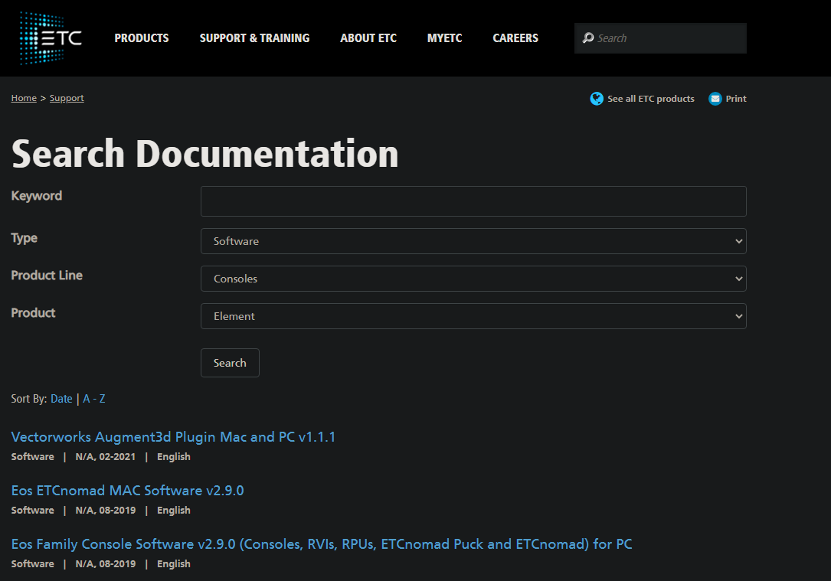

Figure - The Documentation Page

1. If you’re using an apple device, select “Eos ETCnomad MAC Software v2.9.0 (while new softwares are available, this is what we’ll use for these lessons). For PCs, download “Eos Family Console Software v2.9.0.
2. Once the download is complete, run the installer. An administration password to your computer may be required.

Great! You’ve now downloaded show control software onto your computer. So, let’s go ahead and run it.

Different computers may require different methods, but your goal should be to launch the “Eos Family Welcome Screen” or “Launch Eos Family” or something to that effect.

Upon opening this shell, you should be greeted with a message prompting you to “select your console mode.” There exist subtle (but important) differences between normal Eos products and our Element. As such, please select “Element.” This may appear as “Element 2,” this is normal.

Next, you’ll see a variety of options including “Offline w/ Viz,” “Mirror,” etc. For our purposes, “Offline w/ Viz” will be fine. Accept any warning or notice that may appear when selecting this option.

After a moment or two, you’ll be thrown into the Eos software for the first time (yay!).

Your software may look a bit intimidating, but should look roughly like this:

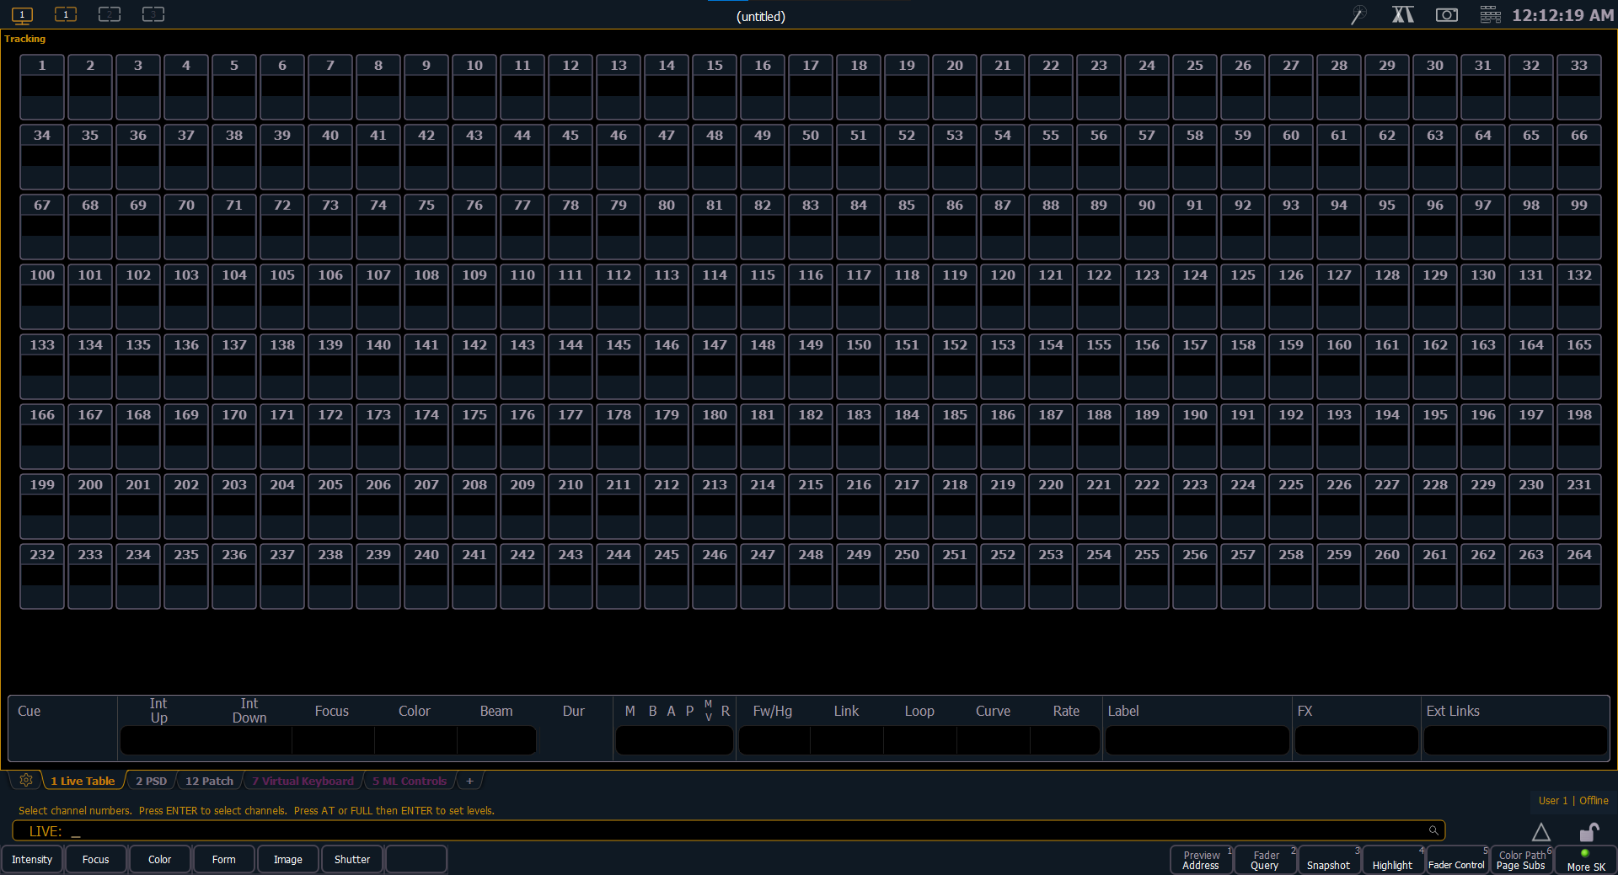

Figure - The Eos Main Screen

Subtle differences are ok, we’ll talk about how to change the look of things later on.

NAVIGATION – GETTING TO KNOW EOS

So, you’ve downloaded this really complex-looking software, and you’re unsure of where to go, how to start, or even how to get out.

The main Eos interface can be broken down into a few key pieces.

1. The Command Line (CLI) – This is where the commands you type will appear as you type them. Your best friend, as it indicates what you’re about to (or have already) done.



Figure - The CLI

1. The Tabs – Each tab is like an app within an app, allowing you to see different types of information in different ways. All open tabs are shown just below your tab. New tabs can be opened with the “+” button and closed by right clicking on the tab name. We’ll examine specific tabs in detail later.

If you’re working on multiple monitors, or want to have more than one tab open at once, click the monitor icon in the upper-left hand corner of your screen to set your tab arrangement.

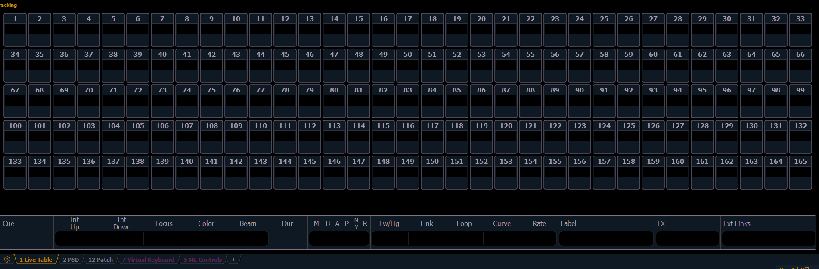

Figure -- An Example of an Open Tab with the Tab List at the Bottom

1. The Central Information Area (CIA) – This area may or may not be shown on your screen by default. To access it, select the white triangle (arrow) in the bottom right-hand corner of your screen (located next to the “lock” icon). In doing so, you should see the following display on the bottom portion of your screen. This is an essential tool for managing files and exiting the program.

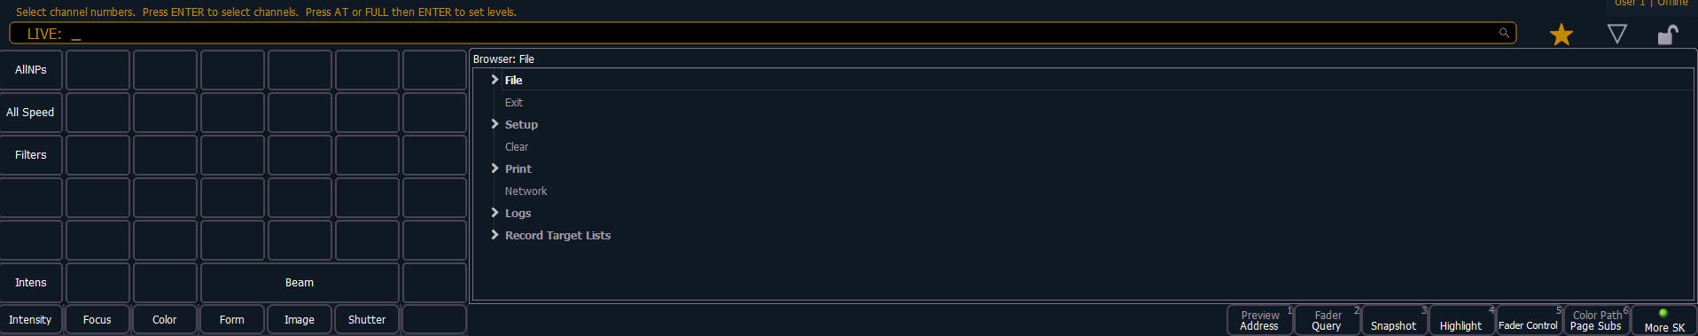

Figure - The CIA

**Specific Tabs**

While we’ll go into more detail later, there are some key tabs and commands you should be made aware of. Try and remember their names, you’ll be using them a lot.

1. The Table (Tombstone) Tab – This is a basic display that shows you the intensity (between 0-100) of each of your channels.

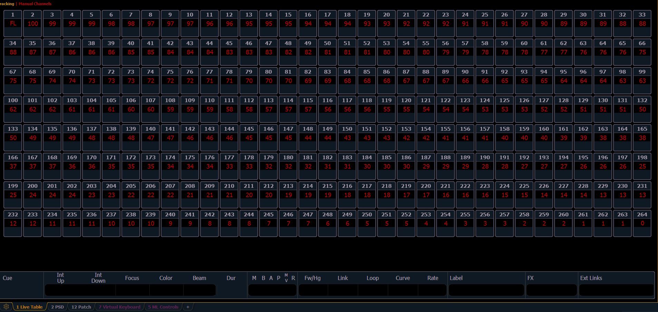

Figure - The Table Display Showing Channels 1-264 at Varying Intensities (shown below the channel #, in red)

1. The Playback Status Display (PSD) – A display that shows you what cue (more on that later) you’re currently in.

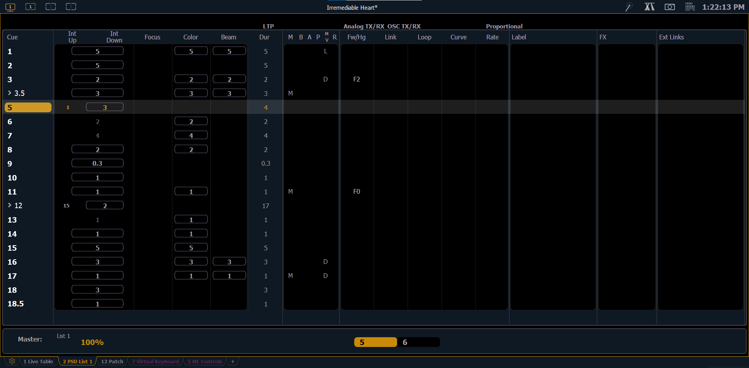

Figure - The PSD showing a list of cues. Cue 5 is active.

1. The Color Picker Tab – Self-explanatory: It lets you select color.
2. The Magic Sheet – This allows you to visualize the location, color and intensity of your fixtures in a 2 dimensional (top down) view.

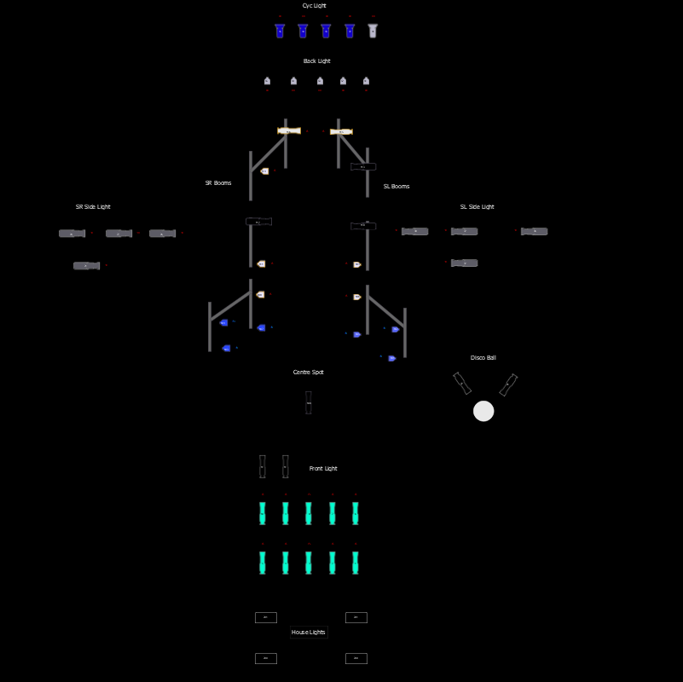

**Exiting the Program**

Being able to exit a program is just as important as being able to enter it. To exit the program, navigate to the CIA and select “Exit.” The software will prompt you to confirm, please do so.

SYNTAX – TALKING TO EOS

Like any computer software, Eos speaks and understands a certain language when it comes to performing tasks. As a programmer/operator, it’s essential that you understand what this language is, and how to properly use its syntax. This next section will detail some of the key terms and phrases you should be aware of.

Channel – As discussed before, the identifying number for each fixture, and the term that allows you to tell the board what fixture you’d like to control.

Intensity – Official term for brightness of a fixture.

Cue – Also written as “Q” on paper, this is the foundation of pre-programmed shows. Each cue is an individual look onstage that is triggered by an action. In most instances, this trigger is the use of the “GO” button (or spacebar on your computer).

Show file – This one seems self-explanatory enough but has led to severe confusion in the past. The show file is the file in which you make cues/groups/other things for a specific show. Starting a new show file is starting a blank slate. As you might expect, 1 show file = 1 show (with some exceptions).

Patch – A verb. The act of assigning that channel number to a fixture. Complicated and outside the scope of this lesson.

Group – A group of channels that can be referred to in the same way as a channel.

Eg. Group 1 🡪 Channels 1-10

Submaster – Commonly referred to as a “sub.” The submaster has been known to cause confusion for those learning lighting concepts for the first time. A submaster is similar to a cue in that it is the recording of a specific look (combination of channels at set parameters). However, a submaster is generally controlled by a physical fader (slider) and things such as intensity are recorded proportionately (more on this later).

Live/Blind – Two of the very basic “modes” of operating your board. Blind is outside the scope of this course but can be identified by a blue display and the appearance of “BLIND” in your command line and upper left corner of the screen. You can accidentally find yourself in blind, but really don’t want to edit there. To return to live, click the “LIVE” button on the physical keyboard, or F1 on your laptop. 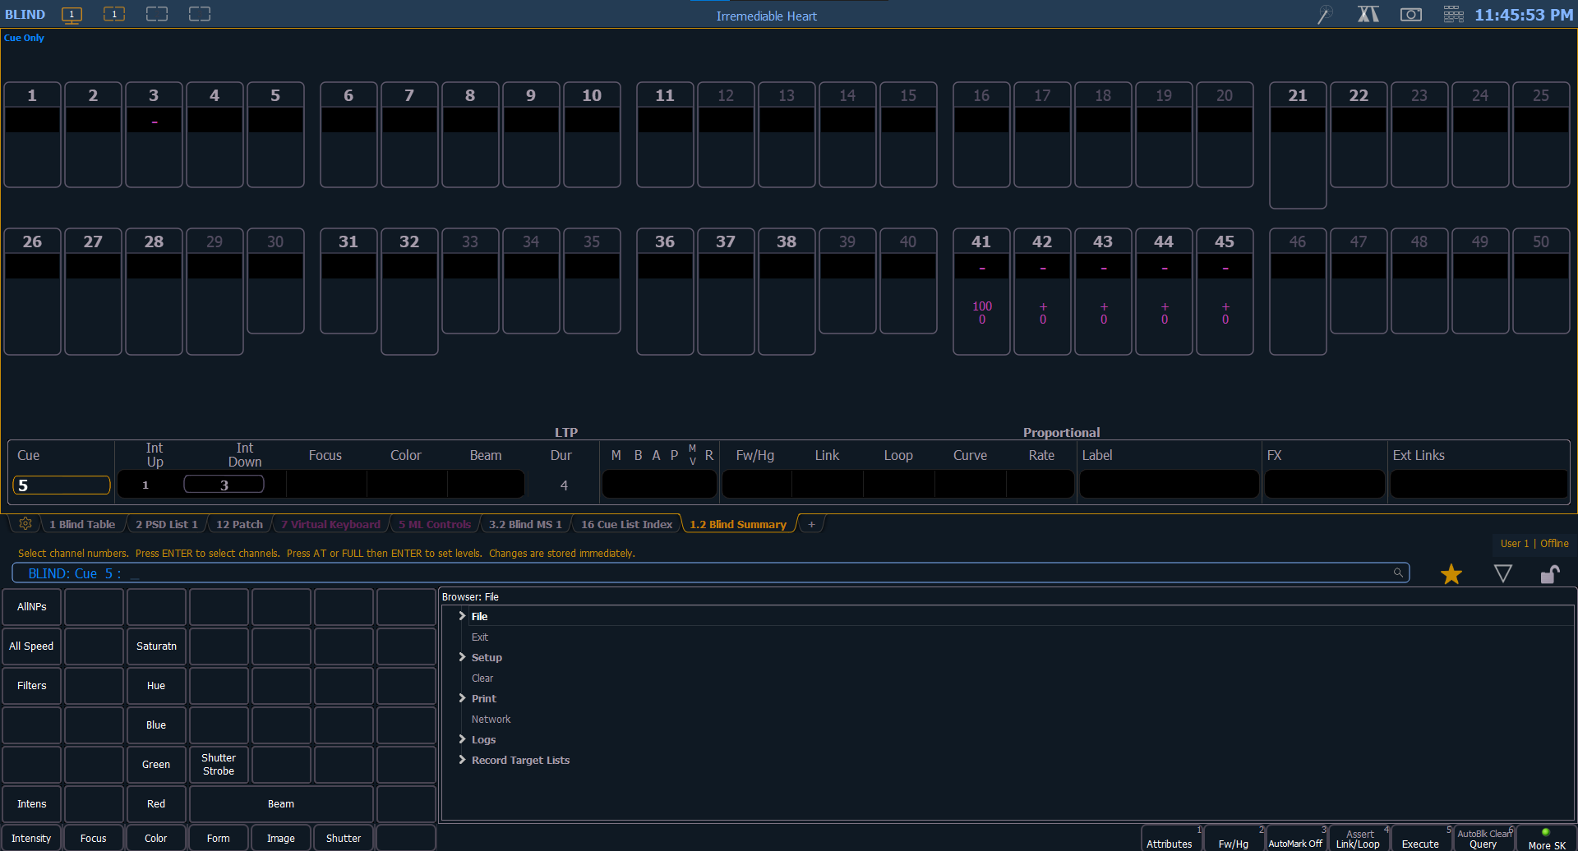

Figure - Display in Blind. Note the appearance of "BLIND" in the CLI in contrast to the standard "LIVE" indicator.

Delete – Exactly that.

Record – Ditto.

Update – Updates something such as a cue, NOT THE SHOW FILE. Use save for that functionality. These make sense, don’t they?

Copy to/Recall from – Two different ways of doing the same thing. Either copying data to a new location (eg. From one cue to another) or bringing data to a location from another.

Blackout – Sets all intensity values to zero (ie. the stage goes black); overrides everything.

Grandmaster – Fader that controls all intensity values proportionately; overrides everything.

Time – Refers specifically to the transition time between two cues.

Flexi – A really neat feature that allows you display only specific types of data (eg. Only showing patched channels or selected channels in your table display).

Go To Cue – Jumps to a cue – Default 5 seconds.

Sneak – Returns you to your saved cue state (a sort of undo button, as long as you haven’t saved your changes). Default of 5 seconds transition.

Softkeys – Located on the bottom-right corner of your screen, these are command keys which change depending on what currently exists on your command line (opposite of your “hard key”).

Full – 100%

Out – 0%; Self-Terminating

Clear – Your friendly backspace button.

There are plenty of other commands, but these are the basics and are the ones that you’ll use 95% of the time for basic programming.

COMMANDS

Congratulations! You now know the terminology, but how do you use it?

Using your command line as an interface, talking to Eos is relatively simple. Most commands you can give are structured similarly to the English language. At the most basic level, these commands can be made up of a noun and a verb. As you become more advanced, you can add on qualifiers and other, more complex, parts. However, for now, we’ll focus on the simplest of commands.

To set a channel intensity:

[1] [at] [50] [Enter]

What have we done here? If you take a look at your command line, it should say “Chan 1 @ 50”

Congrats, you have now set channel 1 to an intensity of 50!

Now, in typing this, there are a few things of note. Firstly, the software automatically implied that you were referring to a channel number when you typed [1]. As such, there is no need to specify “channel” manually. Secondly, notice the use of [Enter]. Most commands in Eos are *terminating* commands, meaning they require the use of the enter button in order to take effect. There exist *self-terminating* commands, such as the use of [Out], that will take effect without the need to press [Enter]. A little yellow diamond, shown below, indicates that a command has been terminated. Any new keystrokes will clear your command line and start a new command. A good habit is to press clear to clear your command line before entering new commands.



Figure - Success!

Note in your table display that channel 1 now has a value of 50.

Now, what happens if we replace [50] with [5]? First, check that your command line is clear (you may need to press clear more than once, depending on your command line situation).

[1] [at] [5] [Enter]

Interesting…The same result. Eos realizes that you’re unlikely to ever set an intensity at less than 10. As such, any single digit will be treated as a 10’s value. 2 = 20, 7 = 70, etc. Should you want a value less than 10, [05] will work. [Full] is better to use than [100], but either are technically acceptable.

Feel free to try setting other levels! Your magic sheet (provided you have one set up) and table should show your updates as you make them.

To attempt a self-terminating cue, try:

[1] [Out]

Notice there was no need to use [at] or [Enter] here. [Out] is a self terminating command, and will instantly take the intensity of your channel(s) to 0, no confirmation needed.

Now, let’s try recording a cue. This command is another simple one, and as you might expect, looks like this:

[Record] [1] [Enter]

Check your PSD, there should now be a cue 1. Again, note that Eos inferred you were referring to a cue. If you wanted to, you could place [Group], [Sub], or [Cue] before the [1] to confirm what exactly you wanted to record.

If you’re building a show and can’t remember what cue you’re on, you can also try:

[Record] [Next] [Enter]

Eos will record the next free integer upon receiving this command.

Cues are often numbered in both whole number and tenth increments. It is common to start with cues 2 and 3 and insert a cue 2.5. Following this, you could add 2.7, 2.9, and even 2.95. Beyond this point, consider how you’re building your show.

Let’s add on to this command a bit. Change some of your levels in order to create a new look on stage, and enter the following command:

[Record] [2] [Time] [3] [Enter]

As you might guess, this records cue 2 and assigns it a transition time of 3 seconds.

It is not uncommon to see time values between 0 and 60 seconds. Most fades are between 2 and 10 seconds, with 0 being called a “snap.”

The time command is incredibly useful, and in conjunction with other commands, allows you to program increasingly complex sequences (imagine a 2 minute sunrise with multiple phases).

Next steps:

1. Build some more cues.
2. Make changes to your cues, and then update them.
3. Attempt to change the time on a cue that has already been recorded.
4. Attempt to delete a cue.
5. Record a group of channels and set a level to that group.

These commands sound quite a bit like natural language, so keep that in mind when programming. Keep your commands short, simple and similar to the format you might instruct someone else to do them (eg. “record cue 1” or “set channel 4 at full intensity”).

We’ll hold off on submasters for now – those are better explained in front of a physical board.

COLOR

Finally, let’s take a quick look at color. While we won’t dive into the complexities of color theory, some basic knowledge is required to be able to create an artistic look onstage.

When you open your color picker, you’ll notice three key areas. The first of these is the spectrum display, which displays all the available colors that your fixture can display.

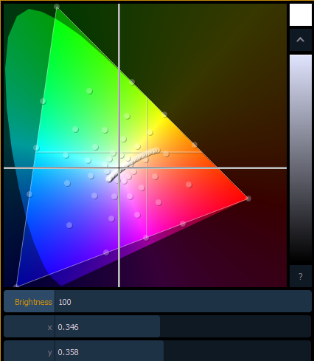

Figure - Spectrum Display

The second of these areas is the list of colors, on the right hand side. Between the two areas is a menu list, allowing you to select the brand of color you’d like to find. In our theatre, we’ll most commonly be using “Lee,” “Rosco,” and “Standard Colors.”

To select a color, first select the fixtures you’d like to change, and then the color you’d like to change them to, no termination required.